Sursa : <https://docs.luxonis.com/software/>

IMPORTANT: <https://docs.luxonis.com/software/depthai-components/pipeline/#depthai.Pipeline.createSpatialLocationCalculator> aici sunt toate functiile ce se pot aplica pe un **pipeline**



IMPORTANT: <https://docs.luxonis.com/software/depthai-components/nodes/> diferite functii ce se pot aplica pe noduri

Pipeline-ul definește ce sarcini vor fi executate pe dispozitiv, reducând astfel sarcina pe computerul gazdă -> ca sa nu iei de pe unframe toate posibilitatile, pipeline ul iti ia doar ce ai nevoie

**Pipeline-ul simplifica si optimizeaza fluxul de informatii ce vin de la camera in cod.**



Pentru detectia cercurilor din imagine:



**dp=** arund 1.2-1.4

**minDist**= distanta dintre 2 centru ale 2 cercuri

- daca vrem un singur cerc, punem numar mare

**Param1** = sensitivity

-daca e prea mare nu va gasi suficiente cercuri, daca e mic, gaseste multe cercuri

**Param2** = accuracy of circle detection, number of edge point that are needed to declare that there is a circle

-too high, nu va gasi suficiente, too low, many circles

**minRadius**= minimum size of the circle can be detected

**maxRadius**= cand se apropie de camera, creste diametrul

* Returneaza o lista de cercuri care au aceasta proprietate

Link care m-a ajutat sa fac: <https://www.youtube.com/watch?v=RaCwLrKuS1w>

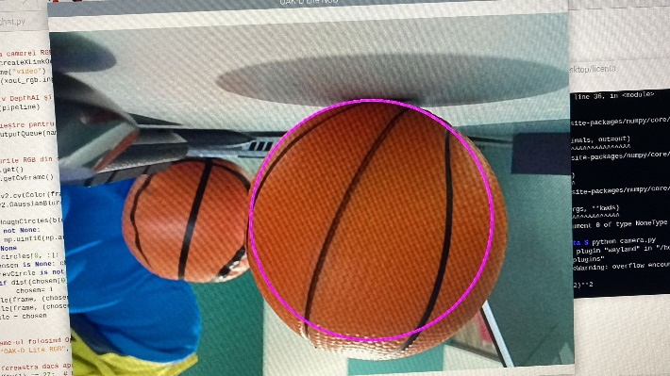

Pentru a detecta culori:

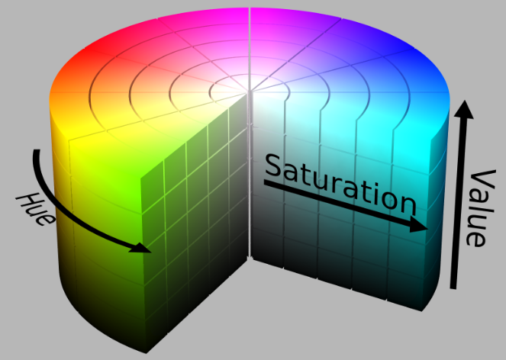 Sursa: <https://www.react-graph-gallery.com/what-is-a-color>